**CSC430/530 – Database Management Systems**

Instructions to Install MySQL Server

**If using Windows, WampServer can be installed:**

1. Download WampServer using the following link: <https://sourceforge.net/projects/wampserver/>

**Click on download**

1. Once downloaded, install it from your downloads

1. Click on the file to proceed with the installation

**ISSUE 1:** If you’re encountering any Microsoft VC++ distribution packages missing error while Installation,

* Make a note of the missing C++ Distribution files,
* Go the Link <https://wampserver.aviatechno.net/>
* Find the downloadable links for the missing files on the website and install them

* Once all packages are installed, restart your computer to apply the changes
* Click on the downloaded WAMP server to proceed with the installation. If it still displays the same issue again, you have more packages to download.

1. Once installed, Choose **“Yes”** for both default browser and default text editor. Choose whatever browser and text editor you want.

1. Click Next and finish your installation.
2. Press the Windows key and start typing "wamp", you should see the program come up in the list. Press enter when you do.

1. When it starts running, there will we an icon in your taskbar. it will turn orange at first

After waiting for some time, it should turn green. This may take a few seconds up to a minute.

**ISSUE 2:** If the icon doesn't turn green after a minute (or two), or it turns Red, you might need to set your ports correctly,

* Right click on the icon 🡪 Tools 🡪 Check State of services
* Window should appear showing the status as below. In my case, it indicates MySQL and MariaDB are started, but apache64 is not started.

**Reason**: PORT 80 is not free on my machine.

**Solution**: Reconfigure to Port 8080`

* Right click on that icon 🡪 Tools 🡪`Click on “Use a port other than 80” 🡪 Enter 8080 and click ok

* Similarly, if any of the other two services are down, MySQL needs Port 3306 and MariaDB needs Port 3307
* Incase if 3306, 3307 are busy, free them up looking for their PID ‘s using your command prompt.

The following commands should be helpful:

For finding the PID

For finding the process

* Once you know the running services on both the ports, go to your task manager (CTRL + SHIFT + ESC) and end them.

If the icon is now showing Green, you are good to go.

1. Go to your browser

* If your Apache server is on port 80 visit <http://localhost/>
* If it’s on port 8080 visit <http://localhost:8080/>

1. WampServer is now installed!
2. One quick thing we need to fix is the default store engine for new tables. By default, this is MyISAM which doesn't support foreign keys. We want to change this to InnoDB. To do this, left click on the "W" tray icon, go to MySQL then "my.ini":

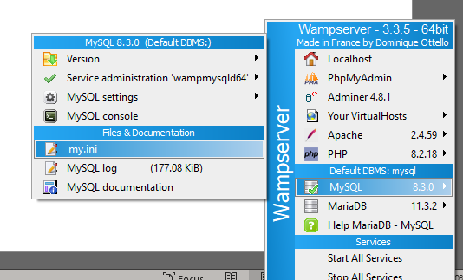

1. Clicking on this takes you to a configuration file. Go to line 63 and you will find this:

default_storage_engine=MYISAM

1. Change this to:

default_storage_engine=InnoDB

1. Save the file and restart WAMP Server. Now all tables created will default to InnoDB.

For further help, this youtube video may be of assistance: <https://youtu.be/1ZXnMsBEUDk?feature=shared>

**If using Mac or Linux (or you have trouble installing WAMP), MySQL Workbench can be installed:**

MySQL Installer Utility for Windows: <https://dev.mysql.com/downloads/installer/>

MySQL installation on macOS: <https://dev.mysql.com/doc/refman/8.0/en/macos-installation.html>

MySQL installation on Linux: <https://dev.mysql.com/doc/refman/8.0/en/linux-installation.html>

I believe the default storage engine for MySQL Workbench is already set to InnoDB, so you shouldn't have to changing it like you would for WAMP.